

SmartChat Proposal for WeCom:

Automating

Sales Quotation System

With

Artificial Intelligence (AI)

Table of Contents

1. Introduction 3
2. Project Objectives 3
3. Current Challenges 4
4. Proposed Solution: Leveraging SmartChat for Automated Quotations 4
5. Solution Architecture 6
5.1. Architecture Diagram 6
5.2. Sentient Cloud Deployment 7
5.3. No Hardware Investment Required 8
6. Key Features and Benefits of SmartChat for Quotation Automation 9
7. Project Approach 9
8. Key Risks and Mitigation Strategies 10
9. Solution Differentiator and Benefits 11
10. Vendor Qualifications 11
11. Budget Proposal 12
12. Project Milestones 13
13. Support Terms and Conditions 14
14. Next Steps 14
15. Call to Action 15

1. Introduction
We understand that WeCom Engineering Pte Ltd is seeking an automated customer quotation system to streamline its sales process and improve efficiency. WeCom, a leading provider of fiberglass piping solutions, valve repair, pump servicing, and engineering assistance, requires a solution that can address the challenges of a high turnover in the sales team and the need for consistent and accurate quotations.
This proposal outlines how SmartChat, our AI-powered conversational platform, can be tailored to meet WeCom's specific needs by automating the creation of customer quotations and integrating seamlessly with your Xero ERP system. SmartChat will empower your sales team, reduce reliance on experienced personnel for standard jobs, and provide valuable insights into your deal pipeline through a customizable analytics dashboard.

2. Project Objectives
The primary objectives of implementing SmartChat for WeCom are to:
- Enhance Operational Efficiency and Reduce the Operational Burden on Staff: Automate responses and guidance for a wide range of quotation inquiries to reduce staff workload. Utilize Artificial Intelligence (AI) to assist in handling complex inquiries, freeing up staff for critical tasks.
- Improve Internal Communication: Provide a customizable analytics dashboard with reports so WeCom has better insights into their deal pipeline and sales team performance at their fingertips.
- Integrate with Existing Systems: Import the approved quotation into XERO.
- Provide Structured Quotation Generation: Implement customizable workflows to guide the quotation process, ensuring consistency and accuracy.
- Offer a Scalable Solution: Implement a solution that can handle an increasing volume of quotation requests, ensuring sustained performance and responsiveness as operational demands grow.
- Empower New Sales Team Members: Provide AI-driven assistance to new sales staff for service pricing and quick response to customer inquiries, reducing the learning curve and reliance on senior staff.

3. Current Challenges
We understand that WeCom is currently facing the following challenges:
- High Turnover of Sales Team: This results in new sales staff frequently needing guidance on how to quote for jobs.
- Potential Loss of Trade Secrets: Ex-staff may bring company trade secrets to competitors. While SmartChat cannot directly solve the high turnover issue or prevent the leakage of trade secrets, it can mitigate some of the associated pain points.
- Inefficiencies in Quotation Generation: Difficulty in quickly generating accurate and consistent quotations, potentially leading to delays.

4. Proposed Solution: Leveraging SmartChat for Automated Quotations
A private enterprise conversational AI like SmartChat offers a comprehensive solution to address WeCom's quotation management requirements. Its advanced features, including a robust AI engine, customizable workflows, and secure deployment options, enhance consistency, accuracy, and speed in the quotation process.
The system will include the following key features:
- AI Assistance for New Sales Staff: SmartChat will be integrated to guide new sales team members on service pricing, enabling them to quickly respond to customer inquiries without extensive training or constant consultation with senior staff.
- Website Integration: A customizable form will be embedded on WeCom's website to collect essential information from potential clients, including their name, company UEN (for Singapore-incorporated companies), required services (using a dropdown list based on WeCom's offerings like Fiberglass pipes, Valve repair, Pump servicing, Engineering assistance, etc.), job site location/vessel name (if applicable), and expected delivery/completion date.
- AI-Powered Quotation Engine: Based on the information submitted through the website form, or from emails from the clients, SmartChat's AI engine will automatically generate a draft quotation. This engine will be trained on WeCom's pricing structures, service offerings, and historical quotation data to ensure accuracy. SmartChat will address most of the standard jobs thus reducing the frequency that the sales team will need to ask for assistance.
- Sales Team Review and Approval: The generated draft quotation will be automatically sent to the relevant salesperson for review and approval. Sales personnel will have the ability to add further information or modify the AI-generated content before final approval.
- Xero ERP Integration: Once the quotation is approved, SmartChat will automatically import it into WeCom's Xero ERP system, eliminating manual data entry and ensuring data consistency.
- Reporting and Dashboard: SmartChat will provide a comprehensive analytics dashboard based on WeCom's specific needs, offering insights into the deal pipeline and sales team performance at their fingertips.
- Email Inquiry Processing: This would further streamline the quotation process for WeCom, reducing manual effort and improving response times for email-based inquiries. To ensure compliance with data security and privacy regulation like Personal Data Protection Act (PDPA), we would work closely with WeCom's IT team to analyze WeCom's email infrastructure and security protocols so that SmartChat can access and process relevant sales inquiries securely and responsibly. We aim to customize SmartChat such that it can intelligently extract key requirement details from emails sent to a dedicated quotation inbox (e.g., sales@wecom.com.sg) and automatically initiate the quotation generation workflow within SmartChat. This advanced integration could potentially involve:
- Intelligent Email Filtering: Implementing mechanisms to automatically identify and prioritize emails containing quotation requests sent to the dedicated inbox.
- Automated Requirement Extraction: Utilizing SmartChat's AI capabilities to automatically extract key information such as requested services, quantities, specifications, and delivery dates from the email body.
- Automated Quotation Initiation: Triggering the SmartChat quotation generation process based on the extracted requirements, creating a draft quotation that can then be reviewed and approved by the sales team.

5. Solution Architecture

5.1. Architecture Diagram

The diagram below shows a schematic representation of the Smartchat quotation system.
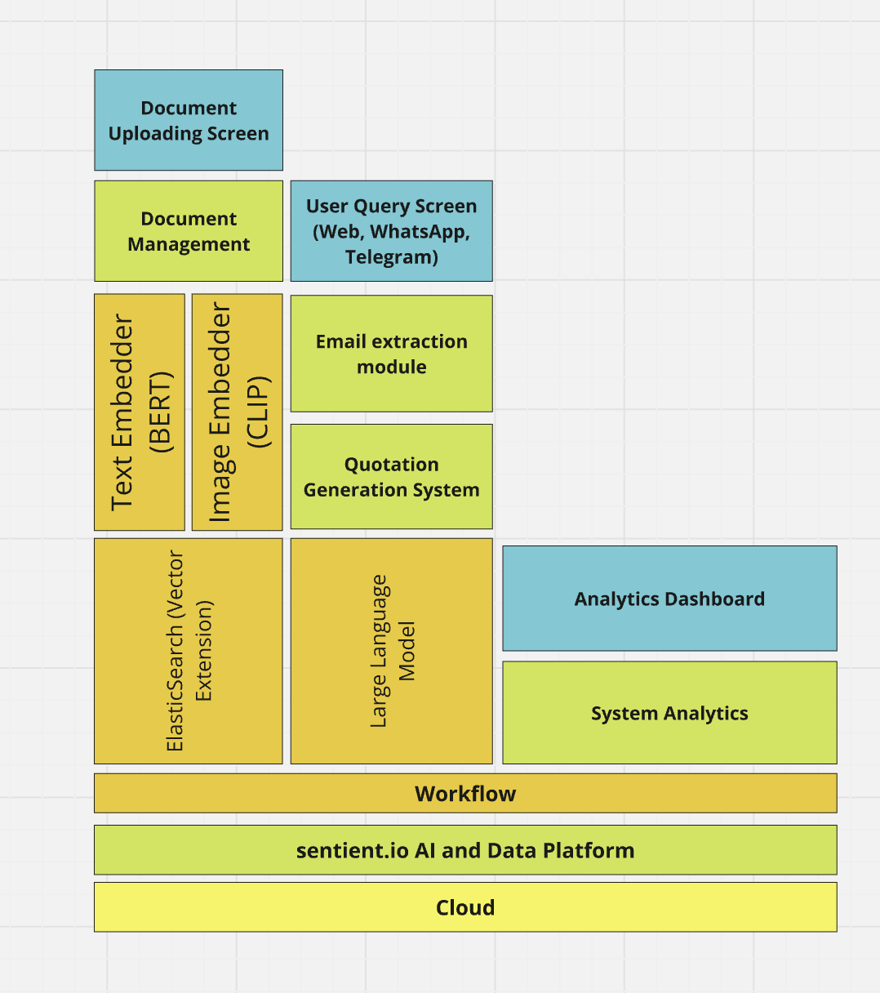
The Sentient SmartChat architecture is designed to enable secure, intelligent, and efficient AI-driven conversations by integrating enterprise knowledge with advanced natural language processing, search, and analytics capabilities. Below is a breakdown of each component:
- User Query Screen (Web): A multi-channel interface that allows users to interact with SmartChat through a web portal. The customizable form embedded on WeCom's website will serve as the user query screen.
- Large Language Model: The AI engine is responsible for processing the customers’ / sales team’s inquiries and generating draft quotations. It uses retrieval-augmented generation (RAG) techniques to fetch contextually relevant responses from indexed documents while ensuring precise and business-specific AI-generated insights.
- Workflow: The orchestration engine that automates and manages the flow of user queries, AI processing, and data retrieval. It connects multiple microservices, ensuring seamless interaction between different AI modules. It supports conditional logic and decision-making processes, allowing SmartChat to execute complex workflows, such as multi-step query handling and intent-based responses. It also enables third-party system integrations, including CRM and enterprise data sources like Xero.
- Email Extraction Module: This module reads and extracts the important product and service request information from the customer’s email and then presents that to the quotation generation system.
- Quotation Generation System: The quotation generation system takes the product and service request from the client, either through the website web form or the client email, and generates the quotation based on the pricing information WeCom supplies to it.
- Analytics Dashboard: Offers real-time insights into SmartChat usage, tracking user interactions, query trends, and performance analytics. This dashboard will be customizable to meet WeCom's specific reporting needs. Part of the Analytics & Reporting suite, providing key usage and engagement metrics.
- System Analytics: Monitors internal system performance, logs errors, and tracks key operational metrics. Ensures system reliability, performance tuning, and security by continuously analyzing AI response efficiency.
- Integration Module: Enables seamless integration with WeCom's Xero ERP system.

5.2. Sentient Cloud Deployment
Sentient proposes utilizing Sentient's cloud infrastructure for SmartChat to implement WeCom Sales Quotation System. The benefits of this approach include:
- Cost Savings: WeCom need not have to invest in costly computer hardware, saving on CAPEX (See section 5.3 below for details)
- Ensured Security: Sentient's cloud environment is designed with robust security protocols to protect sensitive customer and pricing data.
- Reliability and Performance: Sentient's infrastructure is optimized for performance, ensuring system reliability and efficient processing of quotation requests.
- Expert Management: Sentient's team manages the cloud environment, relieving WeCom of the burden of infrastructure maintenance and updates.
- Scalability: Sentient's cloud can easily scale to handle increasing volumes of quotation requests, ensuring sustained performance as WeCom's needs grow.
- Data Privacy: Sentient adheres to data privacy practices and relevant data protection regulations within their cloud environment.

5.3. No Hardware Investment Required
One of the key advantages of deploying WeCom SmartChat on Sentient's cloud infrastructure is the elimination of any need for WeCom to invest in physical hardware as well as manpower to manage the hardware infrastructure. This approach offers several strategic and operational benefits:
- Cost Savings: By leveraging Sentient's secure and high-availability cloud infrastructure, WeCom avoids the capital expenditure and ongoing maintenance costs associated with procuring, installing, and managing on-premise servers.
- Faster Time to Value: With no hardware provisioning required, the solution can be deployed and scaled rapidly. This accelerates project timelines and allows WeCom to begin realising value from the SmartChat application almost immediately.
- Reduced IT Burden: WeCom’s internal IT teams are freed from infrastructure-related responsibilities such as system monitoring, patching, and upgrades. Sentient’s expert cloud operations team manages all backend infrastructure on WeCom’s behalf.
- Built-in Scalability: The Sentient cloud is architected to support elastic scaling, meaning WeCom can seamlessly handle increased user traffic or data volume without infrastructure bottlenecks or procurement delays.
- Sustainability: Cloud deployment reduces the environmental impact typically associated with on-site hardware by utilising shared, optimised data centre resources.
This cloud-first, Software-as-a-Service (SaaS) deployment model ensures WeCom benefits from enterprise-grade performance and security—without the complexity and overhead of owning and managing hardware infrastructure.

6. Key Features and Benefits of SmartChat for Quotation Automation
- Empowering New Staff: AI assistance helps new sales team members quickly learn service pricing and respond to inquiries efficiently, saving the experienced sales team much valuable time.
- Triage: The intelligent AI engine of SmartChat enables accurate interpretation of quotation requests and facilitates structured workflows to support efficient processing.
- Streamlined Quotation Process: Automates the initial steps of quotation generation, reducing the workload on the sales team and increasing Wecom’s productivity.
- Improved Response Times: Faster generation of draft quotations leads to quicker responses to potential clients.
- Seamless Integration: SmartChat facilitates smooth integration with WeCom's Xero ERP system to streamline the end-to-end inquiry-to-sales process.
- Customization: The adaptability of SmartChat ensures that WeCom-specific pricing rules and service offerings can be implemented without requiring complex reconfiguration of the system.
- Scalability: The scalable architecture of SmartChat is designed to handle an increasing volume of quotation requests without compromising performance.
- Reporting and Analytics: Provides a customizable analytics dashboard offering valuable insights to Wecom Management on quotation trends, sales performance, and deal pipeline.

7. Project Approach
Overseeing this project requires a blend of methodologies. Agile development cycles fueled by user feedback will guide the core functionalities, ensuring a user-centric approach to development. To effectively manage this hybrid approach, a visual tool can be utilized to provide a clear view of progress across all stages. Furthermore, fostering open communication and collaboration between teams involved in the project is crucial. Regular meetings and knowledge-sharing sessions will keep everyone aligned and ensure potential roadblocks are addressed swiftly. We will also explore the feasibility of accurately extracting product details from plain text to further enhance the automation capabilities.

8. Key Risks and Mitigation Strategies
While SmartChat leverages advanced technologies, there are potential risks to consider. Here are some key risks and proposed mitigation plans:
- Risk 1: Data Privacy and Security: The system will handle sensitive customer and pricing data. Mitigating data breaches and ensuring user privacy is paramount.
  - Implement robust security protocols and access controls for all integrated systems.
  - Anonymize data whenever possible within the SmartChat system.
  - Clearly communicate data privacy practices and adhere to all relevant data protection regulations.
- Risk 2: AI Bias and Inaccuracies: The AI models used in SmartChat could potentially generate biased or inaccurate quotations if not carefully managed.
  - Focus the AI models on information from WeCom's trusted internal repositories.
  - Continuously monitor AI outputs and implement human oversight mechanisms to identify and address any potential biases or factual inaccuracies.
- Risk 3: System Integration Challenges: Integrating SmartChat with WeCom's website and Xero ERP can present technical challenges.
  - Conduct thorough compatibility testing before full integration to ensure seamless communication between systems and interoperability.
  - Utilize well-documented APIs for each system to streamline integration.
  - Establish a clear communication and collaboration plan between development teams working on different systems.
- Risk 4: Accuracy of Free-Text Extraction: Extracting service descriptions accurately from free-text customer inquiries and linking them to standardized pricing data can be complex.
  - Adopt a hybrid approach, potentially using LLMs for initial text extraction combined with traditional SQL queries for precise database lookups.
  - Conduct thorough internal evaluation and experimentation to identify the most accurate methods for data extraction.
  - Implement human review and validation processes for quotations generated from email inquiries, especially in the initial phases.

9. Solution Differentiator and Benefits
SmartChat offers a unique approach to quotation management by providing an AI-powered private assistant that can understand and process quotation requests in an engaging way comprehensively. This makes it ideal for building an intelligent system that can:
- Enable natural interactions for quotation requests through the website form and email.
- Provide personalized and context-aware draft quotations based on the information provided.
- Offer a user-friendly interface for both customers and the sales team.
- Integrate seamlessly with WeCom's existing Xero ERP system.
- Assist new sales staff in quickly generating accurate responses and quotations.
This combination of intelligence, efficiency, and a user-friendly interface makes SmartChat a powerful tool for optimizing WeCom's quotation process.

10. Vendor Qualifications
Sentient.io Pte Ltd is a local Singapore company committed to delivering innovative and reliable AI solutions. As a local vendor, we understand the importance of supporting Singapore's technology ecosystem and are dedicated to providing strong local support. Sentient.io is also proud to be an A*Star investee company, which means we have access to the research capabilities of A*Star and can leverage their expertise if needed for this project. We have a proven track record in deploying AI solutions for various organizations. For instance, we have successfully deployed a private enterprise conversational AI (SmartChat) for video analytics in MINDEF, demonstrating our expertise in handling sensitive data and complex integration requirements. Our team comprises experienced professionals with a strong understanding of interoperability challenges and user-centric design principles.

11. Budget Proposal
- Project Pricing: The total estimated investment for the implementation of WeCom's automated quotation system is provided below. This includes the software license, customization, integration, and initial training. We will also explore options for phased implementation or subscription models to ease client adoption, as discussed in our meeting.
S/N | Component | Description | Unit of Measurement |  | Price
1 | Sentient SmartChat Platform | WeCom Sales Quotation System on Sentient Cloud | Annual license |  | $18,300.00
2 | WeCom Customisations | WeCom Specific Requirements implementation including automatic scanning and processing of sales inquiry using AI as outlined in Section 4 | One-Time |  | $20,240.00
3 | Professional Services and Training | Project Service and Training | One-Time |  | $10,080.00
 |  |  |  |  | $48,620.00

12. Project Milestones
Milestone | Description | Timeline (from WeCom Proposal) | Payment (% of total project cost)
Milestone 1: Project Initiation and Planning | Detailed assessment of WeCom's current quotation management processes, identification of specific requirements, and project plan development. | 2 weeks | 30%
Milestone 2: Functional (Customization) Requirements sign-off | Configuration and customization of the AI platform to meet WeCom's specific needs, including workflows and rubrics. | 2 weeks | 20%
Milestone 3: System Configuration, Customization, and  Integration with Existing Systems (ensuring interoperability) | Configuration and customization of the AI platform to meet WeCom's specific needs, including workflows, rubrics, and integration of the AI system with WeCom's existing Xero and Email system. | 8-10 weeks | 15%
Milestone 4: User Training and Testing | Comprehensive training for WeCom operators, followed by thorough system testing. | 2 weeks | 15%
Milestone 5: Final Deployment and Go-Live | Deployment of the AI system into the live environment. | 1 week | 20%
Total |  |  | 100%

13. Support Terms and Conditions
During Wecom’s subscription for SmartChat, Sentient.io will provide the following support to WeCom to ensure the continued success of the AI-powered Quotation system:
- System Availability: Aim for a minimum system availability during the contract term, excluding scheduled maintenance periods. Specific details will be outlined in the service level agreement.
- Support: Provide channels for technical enquiries and issue reporting, such as a dedicated communication group or email address.
- Troubleshooting and Response Time: Establish agreed-upon response and recovery times based on the severity of the issue. These will be detailed in the service level agreement.
- Issue Escalation: Define a clear process for escalating issues that are not resolved within the agreed timeframe.
- Scheduled Service Downtime: Plan for necessary scheduled downtime for maintenance, bug fixes, and feature deployments, with advance notification to the client.
- Events Beyond Control: Outline conditions under which neither party shall be liable for failure or delay in performance due to circumstances beyond reasonable control.

14. Next Steps
To realize the benefits of SmartChat for WeCom's quotation automation, we recommend the following immediate actions:
- Customize Workflows: Work with the WeCom team to tailor the website form, AI quotation logic, and Xero integration to align with their specific needs. We will also discuss the customization options for the analytics dashboard.
- Pilot Deployment: Conduct a pilot project to test SmartChat in a real-world setting with a subset of WeCom's services, gathering user feedback to optimize the solution. We will also use this phase to further explore the feasibility of email inquiry processing.
- Training and Feedback: Train WeCom's sales team on using SmartChat, emphasizing its user-friendly features, and gather feedback to refine workflows and features for continuous improvement.

15. Call to Action
Contact us today to schedule a meeting to finalize the project details and commercial terms for implementing SmartChat. We are ready to discuss specific requirements, pricing, and a phased implementation approach to move forward with deploying an efficient, accurate, interoperable, and user-centric AI-driven solution for your operational needs.

